**Interactive Fresh Water Aquarium using IOT**

Aman Khaware (1847209)

Vikash Singh (1847263)

Kumar Navin Barnwal (184767)

**DESIGN SPECIFICATION – DOCUMENT**

**CONTENTS**

1. User Interface design

2. Database design

3. Circuit diagram

4. Data flow diagram

**1 User Interface design**

The user interface design of the application will have the following interfaces.

* 1. **Splash Screen**

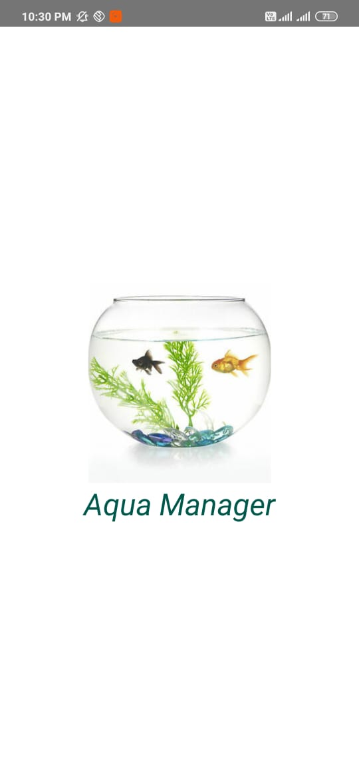

* 1. **Login Screen**

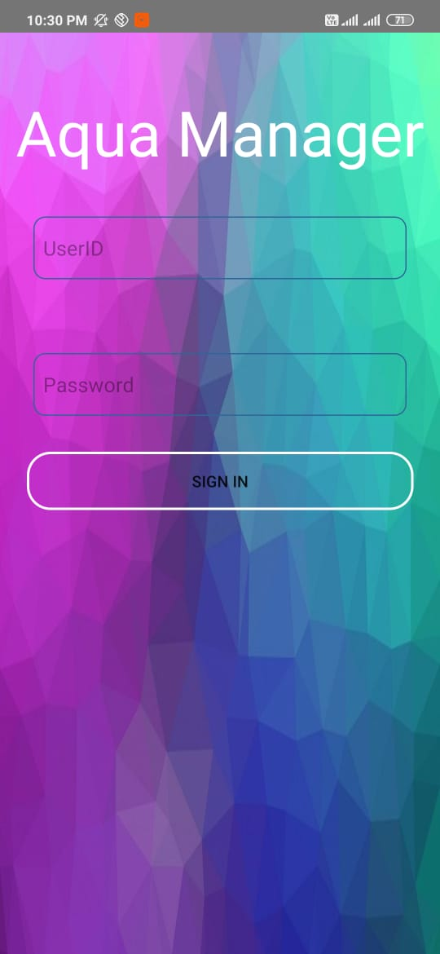

This will act as the login page of the application. The screen will have a field to enter the username and password. Then the user can login to the application and access the features and keep track of the quality of the water in the aquarium.

**1.3 Menu Options**

The menu options consist of Data and Analysis. In this data part it consists of pH value and the temperature along with time and the date and data will be stored in firebase. Analysis consist of details and displays the graph that will be fetched using thingspeak.

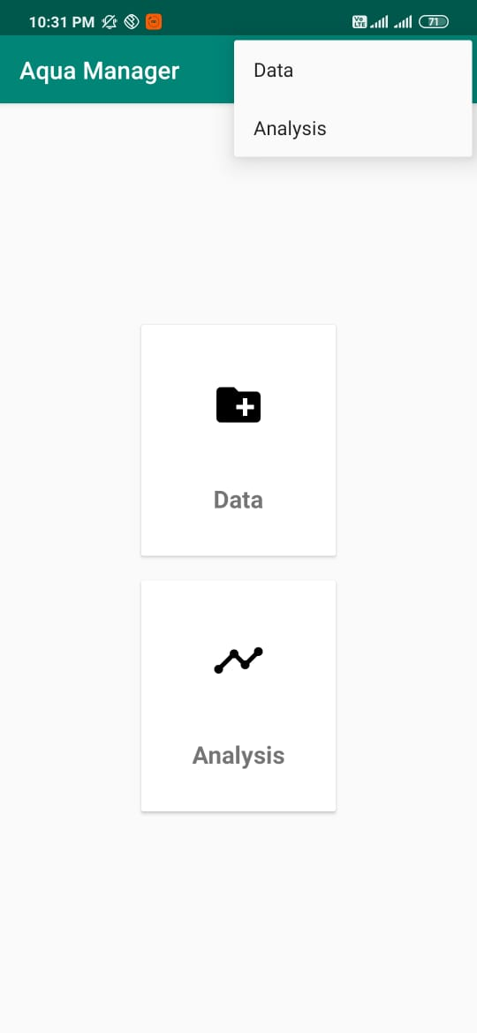

* 1. **Power Button**

Here power icon is used to logout from the page.

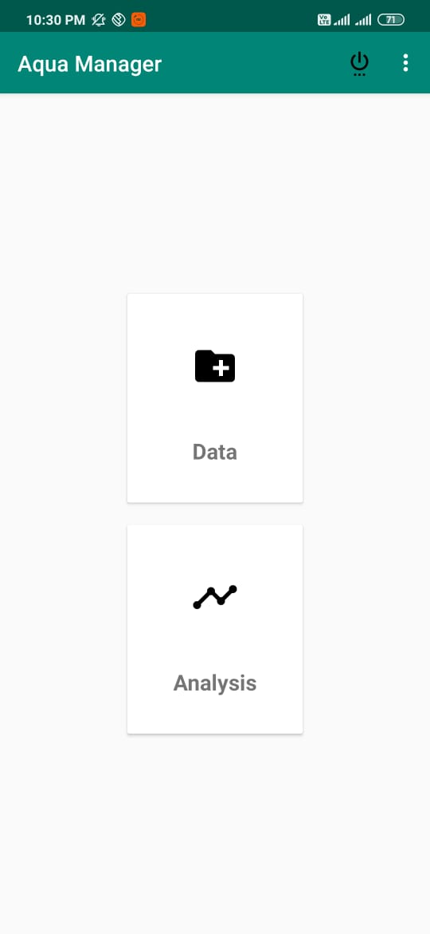

**2 Database design**

The following is the database design of the system. The necessary tables to store the data are included in this section.

**2.1 Details**

|  |  |  |  |
| --- | --- | --- | --- |
| Date | Time | PH Value | Temperature |

The table is storing the pH value and the temperature of the water along with the date and the time and that used to keep track of the water quality. pH value will be stored in pH column and temperature will get stored in temperature column so further analysis can be done using the different values at different dates.

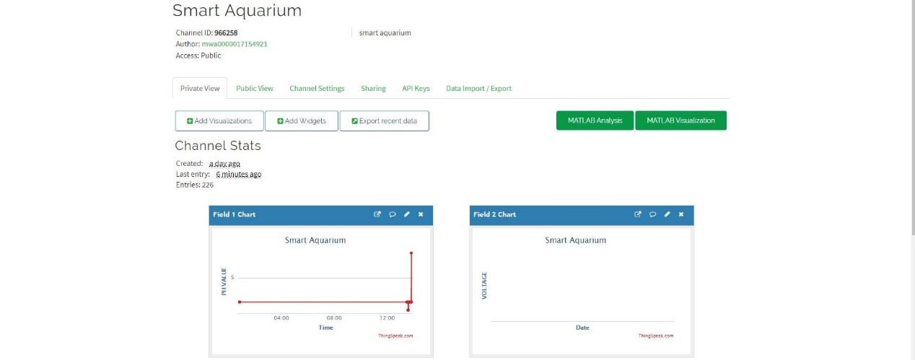

Figure 1 ph Value

**3 Circuit Diagram**

The following is the circuit design of the Interactive Fresh Water Aquarium.

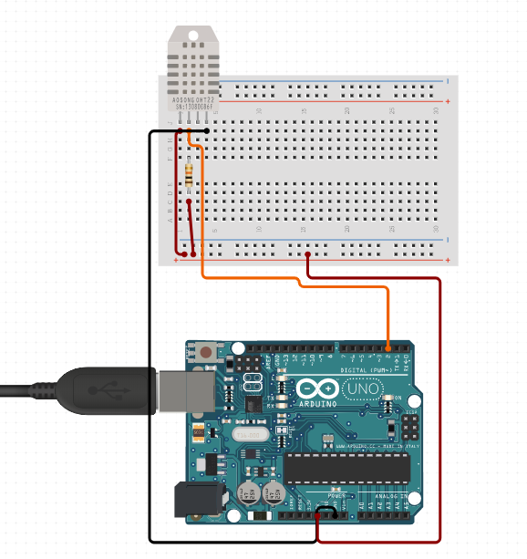

Figure 2 Temperature Sensor

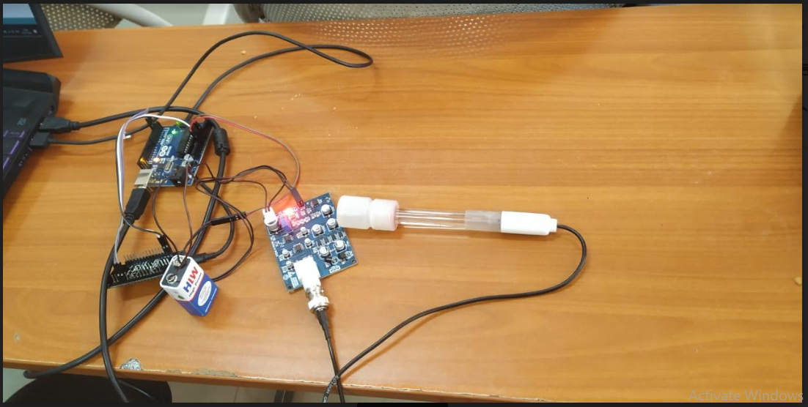

Figure 3 PH Sensor

**4 Data flow diagram**

The flow of data in the device be like as follows:

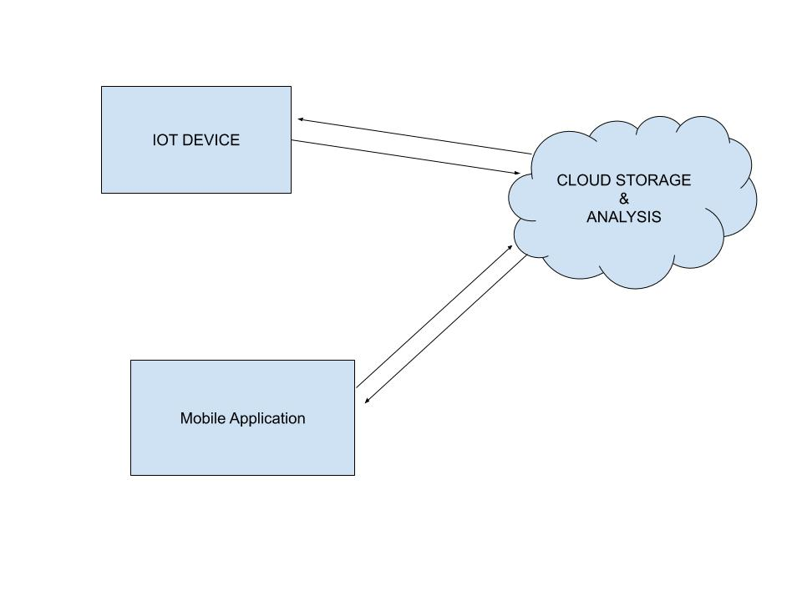

The IOT device will send the data to the cloud storage, the data will be used for some analysis and the result is sent to the user in his mobile application. Also, the real time data regarding the quality of the water in the aquarium.

